**PROJECT REPORT ON**

**DREAM HOMES REALTY**

1. **INTRODUCTION**
   1. **Overview**

Accounting plays anessential role in any business organization as it help to record all transactions and analyse the financial status of the business at the end of the financial year. In this project, we prepare the financial reports of Dream homes realty through zohobooks. With the use of zohobooks,  we did the  transactions  such as set up organisation profile, item creation, vendors creation, customers creation, to make a purchase order, to receive the sales order, to create a bank account, to create a petty cash, payment made to vendors through bank account and petty cash, received the payment from the customers through bank account and petty cash, filling the GST, creation of bills and invoice, making the journal entry and finally we get the reports of profit and loss account and balance sheet.

**1.2 Purpose**

* The purpose of the project is to accumulate the report on financial information about the performance, financial position and cash flow of a business.
* To measure the process of company financial statement overtime and see how it changes.
* This project will help to the company interpret the financial data of a company to understood its true standing of the business

**2. PROBLEMS DEFINITION AND DESIGN THINKING**

**2.1 Empathy map – screenshot**

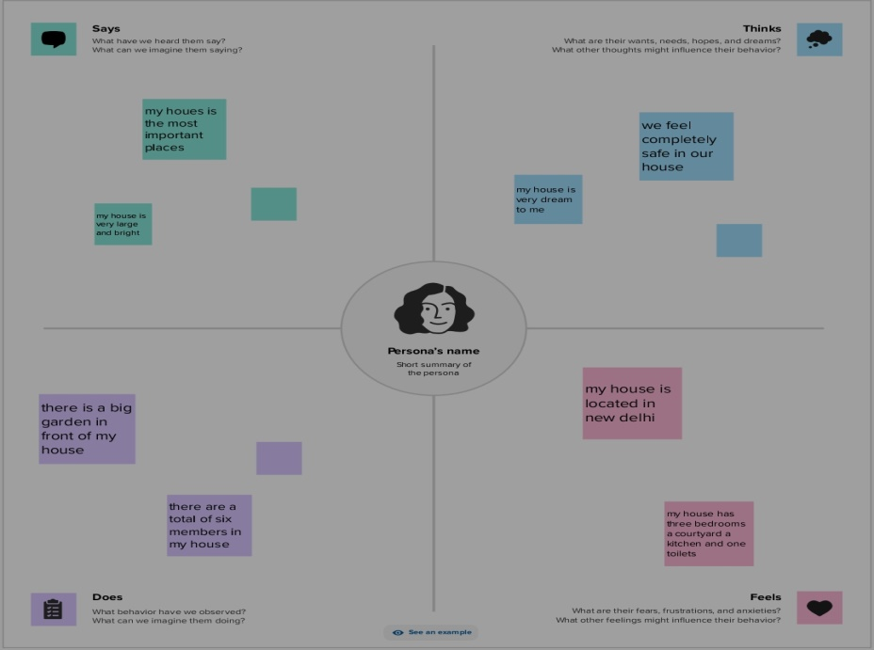

**2.2 Ideation and brainstorming map – screenshot**

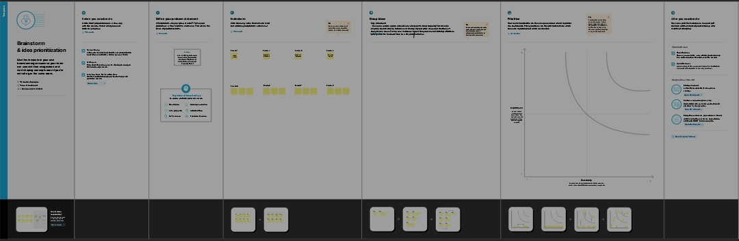

**3.RESULT**

Screenshot - Profit and loss account

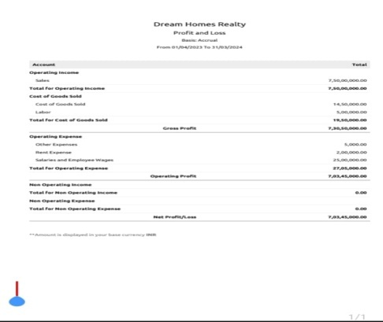

Balance sheet

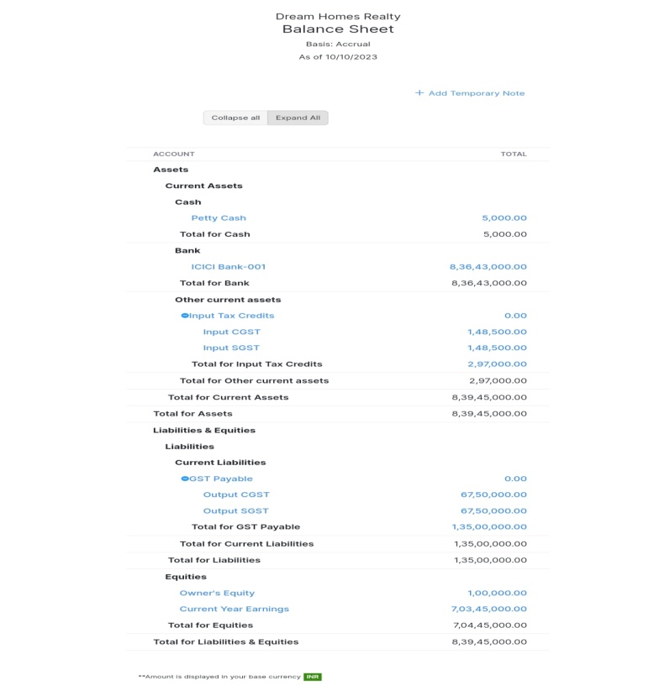

Accounts receivable

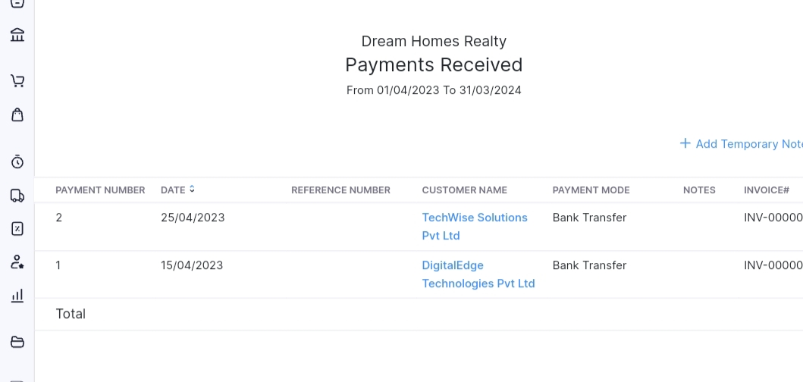

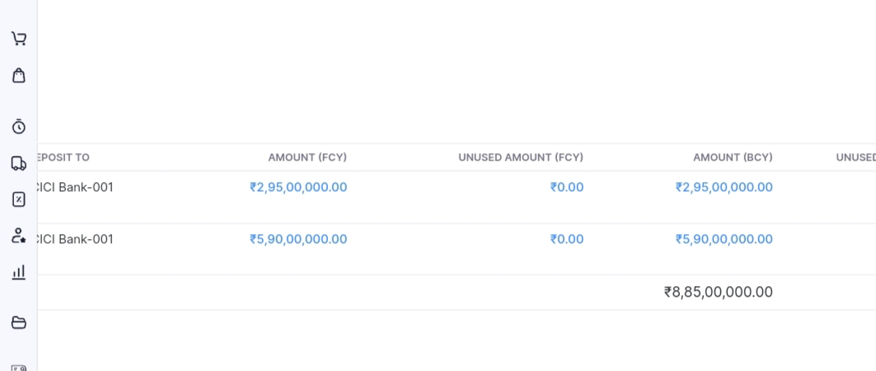

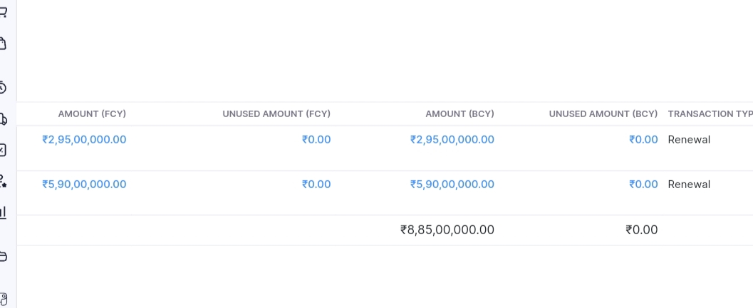

Accounts payable

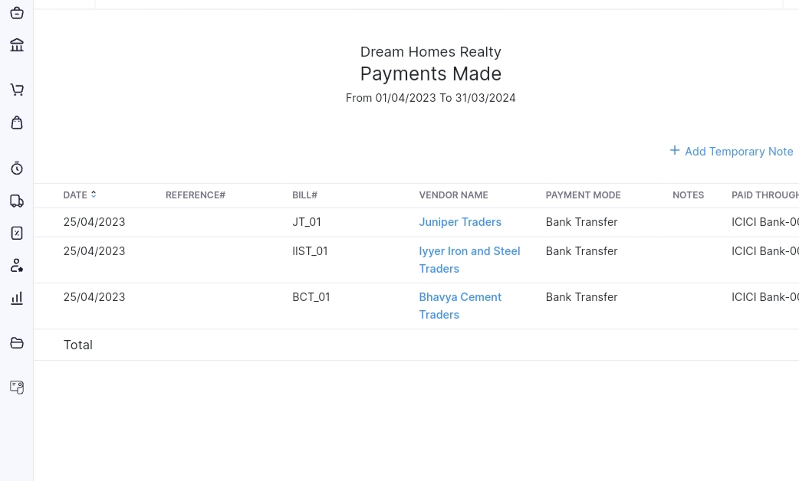

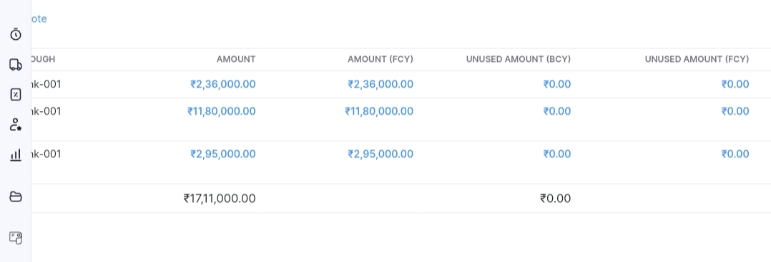

Banking transactions

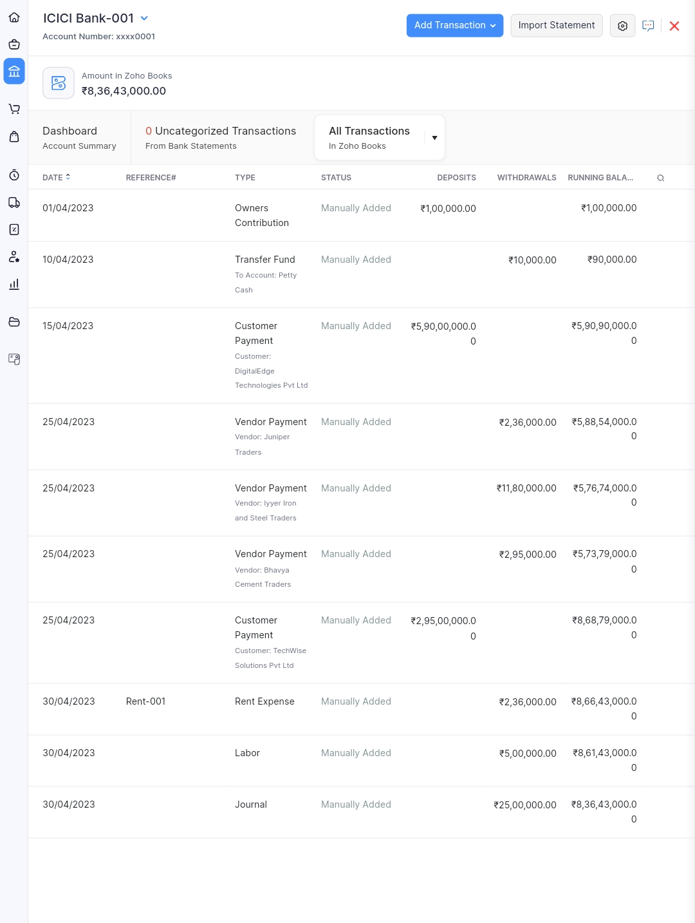

Journal report

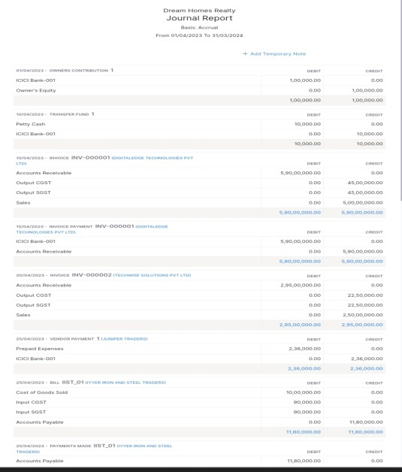

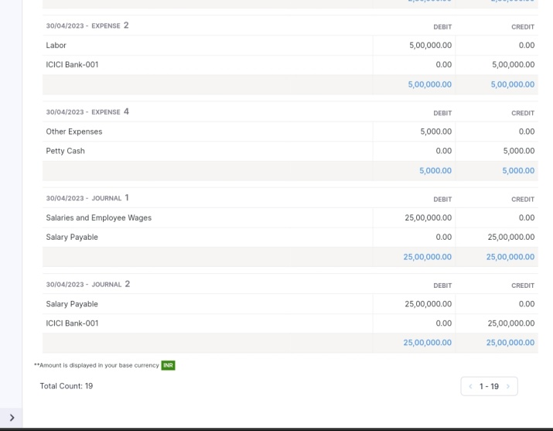

GST report

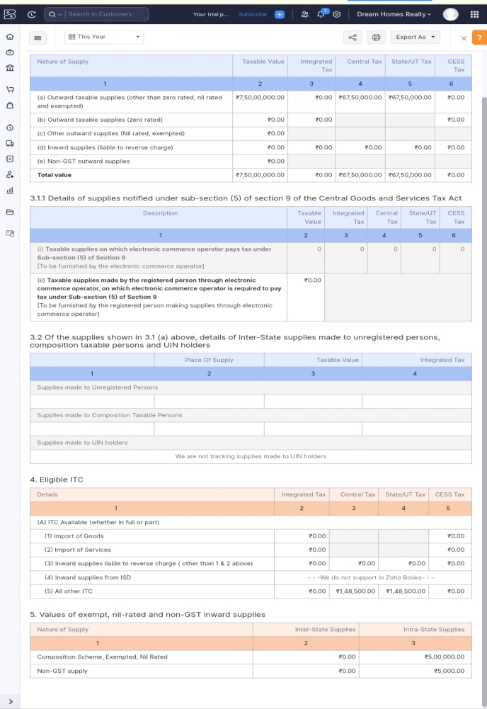

Petty cash

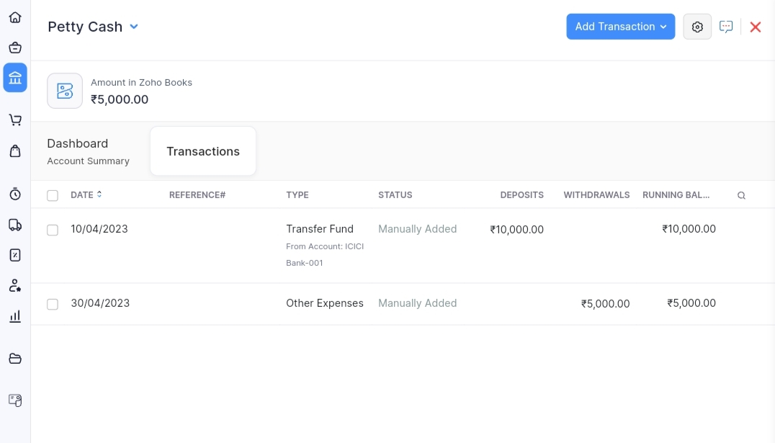

**4.CONCLUSION**

From this project it is clearly indicates that, a summarized a financial statements, which supply an overview of the financial activities of business among a period such as Assets- Rs.

Liabilities – Rs. 1,35,00,000 Bank balance – Rs. 8,36,43,000 Cash balance – Rs. 5000 Trade Payable – Rs. 17,11,000 Trade receivable – Rs. 8,85,00,000 Cost of goods sold – Rs. 19,50,000 GST payable – Rs. 1,35,00,000 GST receivable – Rs 2,97,000 Operating income – Rs 7,50,00,000 and Operating expenses – Rs. 27,05,000 during the year, as well as information about its financial position on a specific date. Furthermore, financial statements help owners in evaluating the performance and position of their business which can guide their investment decisions and also accounting also helps organizations to plan their finances by developing budgets and forecasts.This process helps organizations in planning their finances ahead and controlling any deviations from the budget. Lastly, accounting is a trustworthy process for recording, organizing and analyzing financial information which helps in the effective management of the business.

**5.FUTURE SCOPE**

* This project will be help to business plan for the future by providing insights into how much money they have and how much money they will need.
* It also tracks the performance of a business and helps to make a crucial decision about in future.